Laboratory WORK REPORT №2

«Operational amplifiers circuits design»

**Principles of Circuits**

Student:

Program of Automation

group AT

Name Surname:Li Xin

# Work purpose: to study parameters of Operational Amplifier and basis of Operational amplifiers circuits design

Goals:

1) Design amplifier model on the basis of operational amplifier «Opamp_name»

2) Simulate amplifier scheme and analyze dependencies of output voltage from load and resistor values variation

3) Analyze time domain and frequency domain of amplifier

4) Simulate underpower state/power supply check

# Starting data

* **Required gain of amplifier $K_{NI}=$** -0.75
* **Required tolerance $:{ΔK}_{NI}=4\%∗K_{NI}$**
* **Operational Amplifier :**

**Voltage source power supply** Vcc+ $=3$ (V) / Vee $−=−3$ (V)

**Frequency for time domain simulation**

$f_{test_1}=120$ (Hz)

$f_{test_{2}}=$ 2400 (Hz)

$f_{test_{3}}=$ 240000 (Hz)

**Test signal voltage magnitude**

$V_{test_{AC}}=V_{test}=1.6$ (V)

**Resistor parameters**

$R_{1}=$ 20000 (Ω)

$R_{fb}=15000$ (Ω)

$R_{Load}=$ 1 000 0000 (Ω)

**Amplifier scheme:** Inverting amplifier

# Simulation

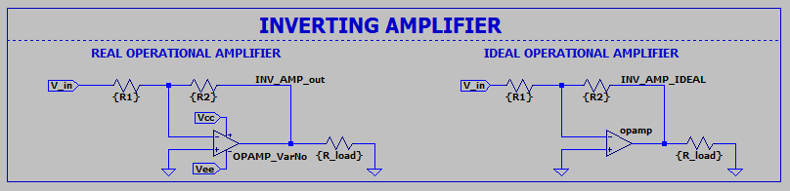

Figure 3.1 – Non-inverting amplifier scheme

## Gain evaluation:

Gain evaluation with new resistors (this example for inverting amplifier)

$K_{NI}=−\frac{R_{fb}}{R_{1}}=$-0.75

$$K_{{NI}_{max}}=\left|−\frac{R_{fbmax}}{R_{1min}}\right|=\frac{R_{fb}(1+M)}{R_{1min}(1−M)}=0.7652$$

$$K_{{NI}_{min}}=\left|−\frac{R_{fbmin}}{R_{1max}}\right|=\frac{R_{fb}(1−M)}{R_{1min}(1+M)}=0.7351$$

You may try summing or subtracting amplifier for 2 **extra** points. You will need to evaluate $K_{{NI}_{max}}$ and $K_{{NI}_{min}}$ by yourself.

Define maximum deviation from ${ΔK}_{NI_{R}}$ defined by resistance tolerance

$${ΔK}_{NI_{R}}=0.0152$$

$$E_{NI_{R+}}=\left|\frac{\left|K_{{NI}_{max}}\right|−\left|K_{NI}\right|}{\left|K_{NI}\right|}\right|=2.02020202$$

$E_{NI_{R−}}=\left|\frac{\left|K_{{NI}_{min}}\right|−\left|K_{NI}\right|}{\left|K_{NI}\right|}\right|=$ 1.98019802

$E_{NI}=$ $2.02020202$

Table 1. Parameters of the amplifier

|  |  |  |  |
| --- | --- | --- | --- |
| Обозначение | Simulation | | |
|  | Nominal | With tolerance variation | |
| R1, kΩ | 20k | 1% | |
| R2, kΩ | 15k | 1% | |
| RLoad, kΩ | 1 000 k (ideal) | 1000, 10000, 100000 | |
| $$K_{NI}$$ | -0.75 |  | |
| $$K_{{NI}_{max}}$$ |  | -0.7652 | |
| $$K_{{NI}_{min}}$$ |  | -0.7351 | |
| $$ΔK_{{NI}_{R}}$$ | -0.03 | | 0.0152 |

## Time domain simulation results

### $f_{test_1}=120$ (Hz)

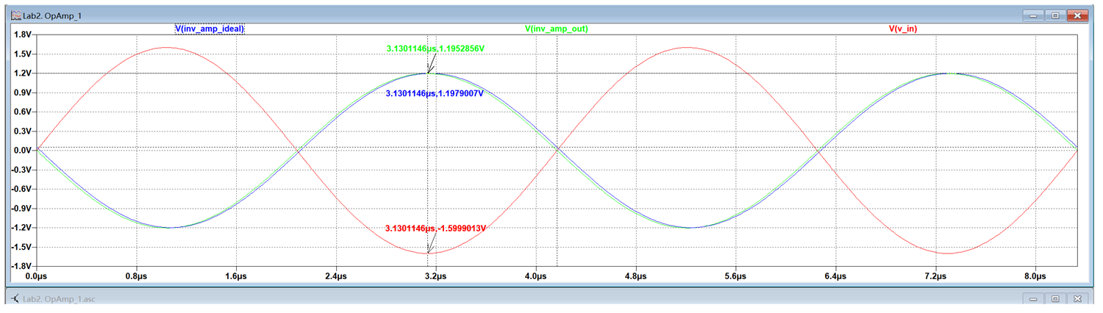

Figure 3.2 – Input and output voltages of ideal and real operational amplifiers

$f_{test_1}=$ 120, $K_{NI}=−0.75$, $R_{1}$ variation 1%, $R_{fb}$ variation 1%

### $f_{test_2}=$ 2400 (Hz)

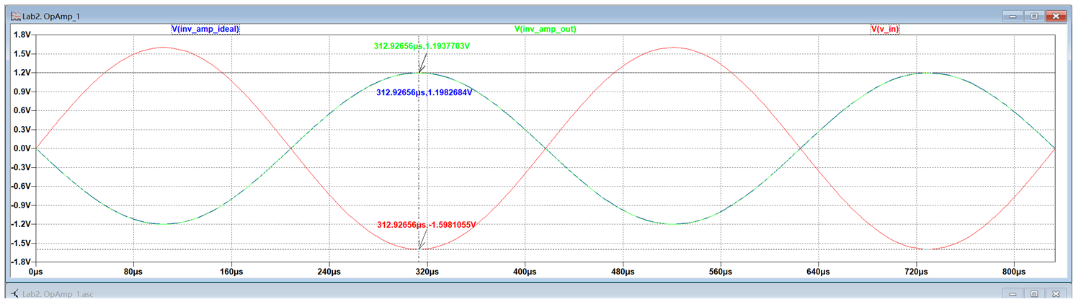

Figure 3.3 – Input and output voltages of ideal and real operational amplifiers

$f_{test_{2}}=2400$, $K_{NI}=−0.75$, $R_{1}$ variation 1%, $R_{fb}$ variation 1%

### $f_{test_3}=240000$ (Hz)



Figure 3.4 – Input and output voltages of ideal and real operational amplifiers

$f_{test_3}=240000$, $K_{NI}=−0.75$, $R_{1}$ variation 1%, $R_{fb}$ variation 1%

## Frequency domain simulation results

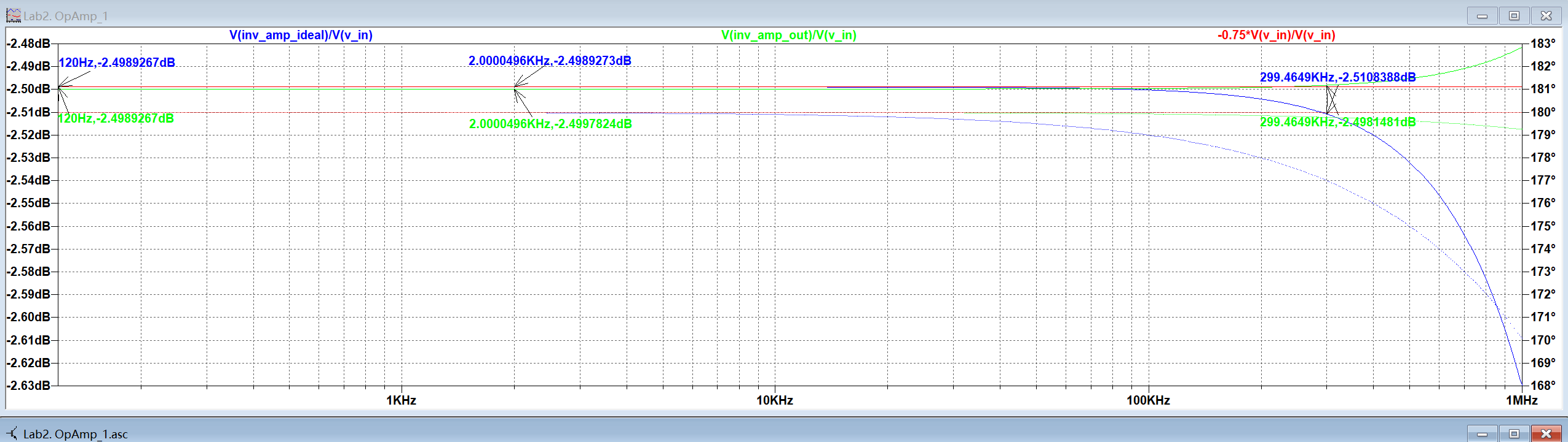

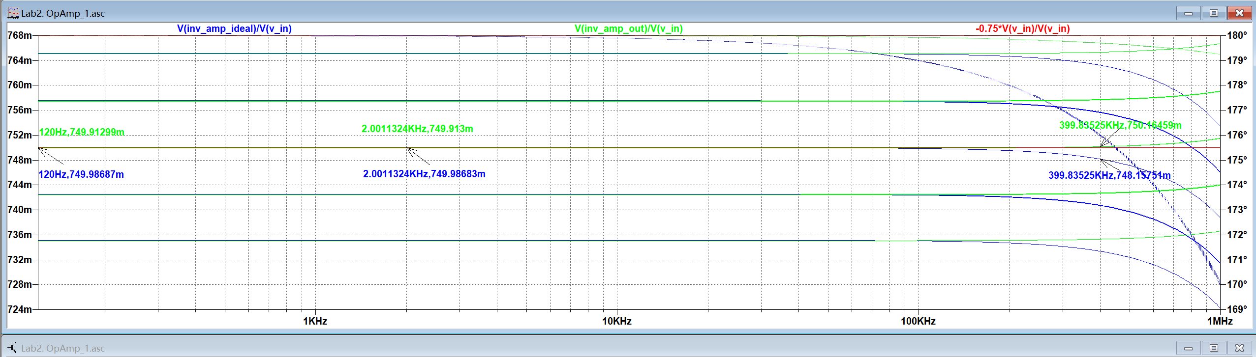

Figure 3.5 – Input and output voltages of ideal and real operational amplifiers

$K_{NI}=−0.75$, $R_{1}$ variation 1%, $R_{fb}$ variation 1%

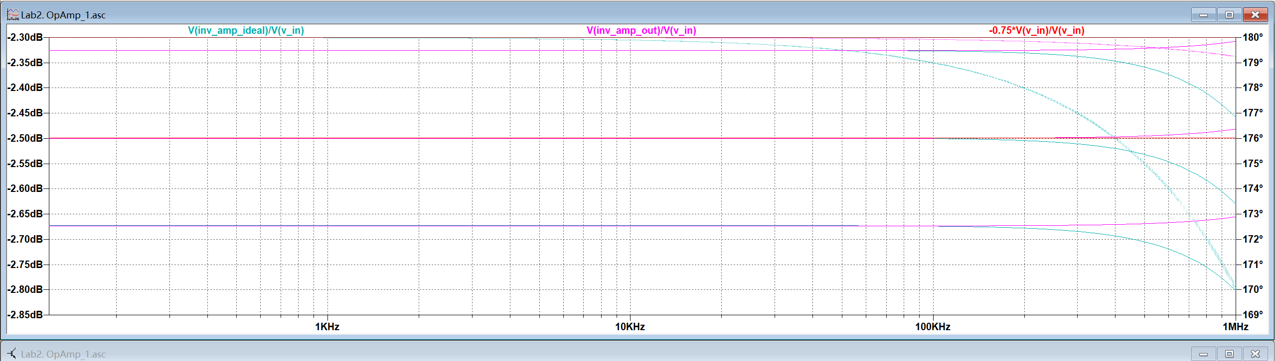

Figure 3.6 – Input and output voltages of ideal and real operational amplifiers

$K_{NI}=−0.75$, $R_{1}$ variation 1%, $R_{fb}$ variation 1% and $R_{Load}$ variation

### Time domain simulation results

|  |  |  |  |  |  |  |
| --- | --- | --- | --- | --- | --- | --- |
|  | **Ideal Opamp** | **VarNo Opamp** | **Ideal Opamp** | **VarNo Opamp** | **Ideal Opamp** | **VarNo Opamp** |
| **frequency, kHz** | **120** | | **2400** | | **240000** | |
| $V_{test}$**, V** | 1.1979007 | 1.1952856 | 1.1982684 | 1.1937703 | 1.1979007 | 1.1952856 |
| $V_{out}$**, V** | -1.5999013 | -1.5999013 | -1.5981055 | -1.5981055 | -1.5999013 | -1.5999013 |
| $$K_{NI_{exp}}=\frac{V_{test}}{V_{out}}$$ | 0.7498 | 0.747 | 0.7498 | 0.747 | 0.7487 | 0.7471 |
|  | 0.0002 | 0.003 | 0.0002 | 0.003 | 0.0013 | 0.0029 |
|  | 0.0003 | 0.004 | 0.0003 | 0.004 | 0.0017 | 0.0039 |
|  | 2830.2446 | 185.4077 | 2891.5225 | 185.4373 | 2891.5225 | 185.4373 |

# Conclusions

Conclusions should contain:

1. Is it possible to realize amplifier with defined gain and gain tolerance?

Yes, it is possible to achieve an amplifier with a defined gain within a specified tolerance range. By carefully selecting resistors with a tolerance, such as 1%, the amplifier can maintain a consistent gain as per design requirements

1. In which range can be load resintace $R_{Load}$ variated?

The load resistance can be varied within the range of 1kΩ to 100kΩ. This range allows the amplifier to operate under different load conditions while maintaining stability and the desired gain performance

1. How was operational amplifier power supply modified?

The operational amplifier’s power supply was adjusted to ensure stable performance under different load and gain conditions. The specific power supply voltage adjustment provided the necessary power for the circuit’s operation